Form No. 6

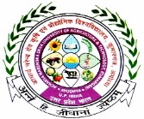 | Acharya Narendra Deva University of Agriculture & Technology,  Kumarganj, Ayodhya-224229 (U.P.) India | 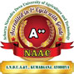
Preliminary Examination (Oral)

We have conducted the preliminary examination (Oral) of Mr./Ms……………. ………………………………….. Id. No. …………………………………… M.Sc./M.V.Sc./ M.Tech./M.F.Sc./M.B.A./Ph.D student in ………………….…………..……. on dated ……………………………………………..… and his/her performance has been found to be satisfactory/unsatisfactory.

Major Advisor & Chairman External Examiner

Members

Major | Minor | Supported Field | Dean PGS Nominee
Or Co-Advisor

Head of Department

Dean of the College

Dean, Post Graduate Studies

